Event Report – 2023-20204
Dept. of Political Science

Sr. No. | Particulars | Report
1 | Event Organising Committee/Club/ Cell/ Association | Dept. of Political Science
2 | Title/Topic of the Event/Theme of the event | Relevance of United Nations
3 | Type of Event(Conference/Competition/Invited Talk) | Essay Writing Competition
4 | Date & Time | 21-10-2023
5 | Venue | Library
6 | Sr. No of Web Portal Activity Register where event is entered | 16 at page no. 4
7 | No. of students/ participants | 17
8 | Name and Address of Resource Person/ Guests/ Speakers/Judges | Mrs. Manjit, Asstt. Prof. of English , GCG, Palwal(kkr)  Mrs. Komal, Asstt. Prof. of Commerce, GCG, Palwal(kkr)  Dr. Sapna, Asstt. Prof. of Computer Science, GCG, Palwal(kkr)
9 | Any Other information about the event-Brief Report | NIL
10 | Photograph( 4 General & 2 Geotag) | 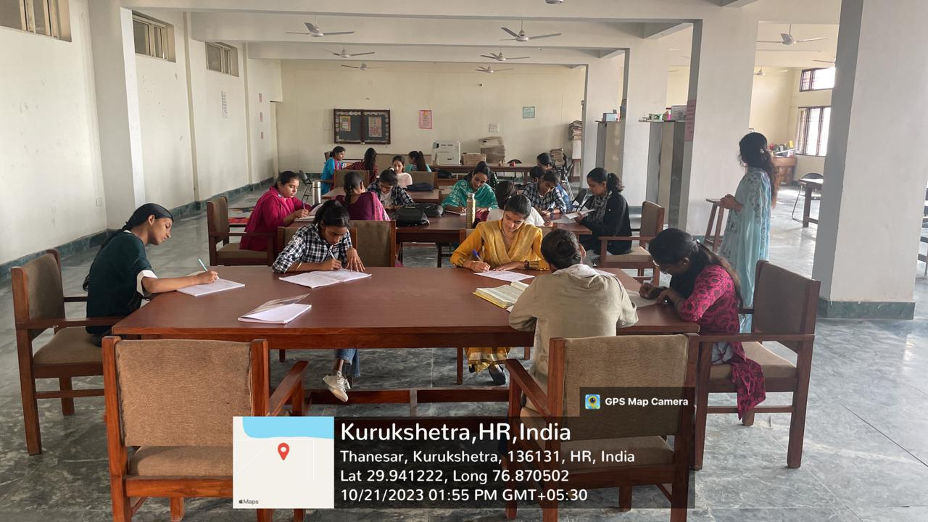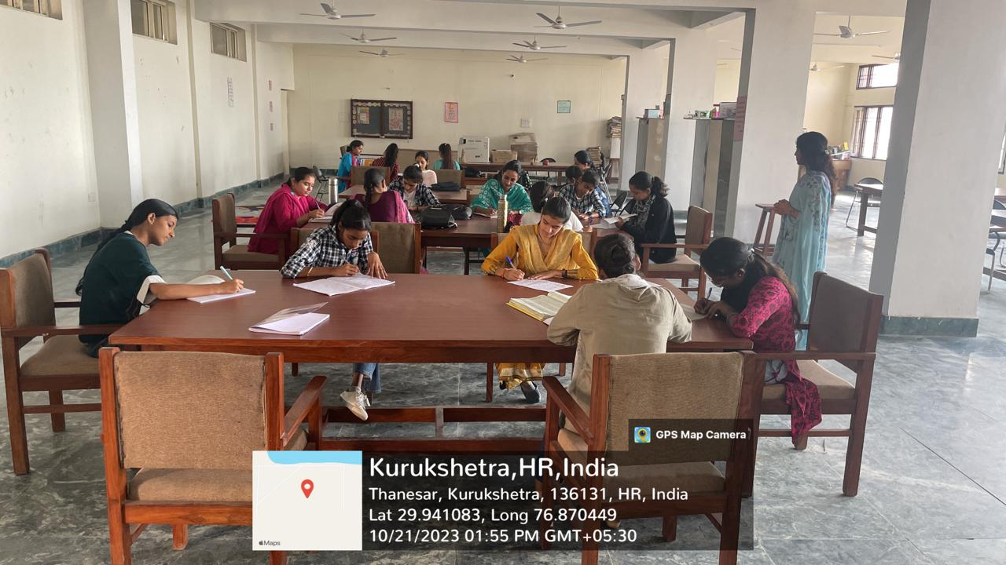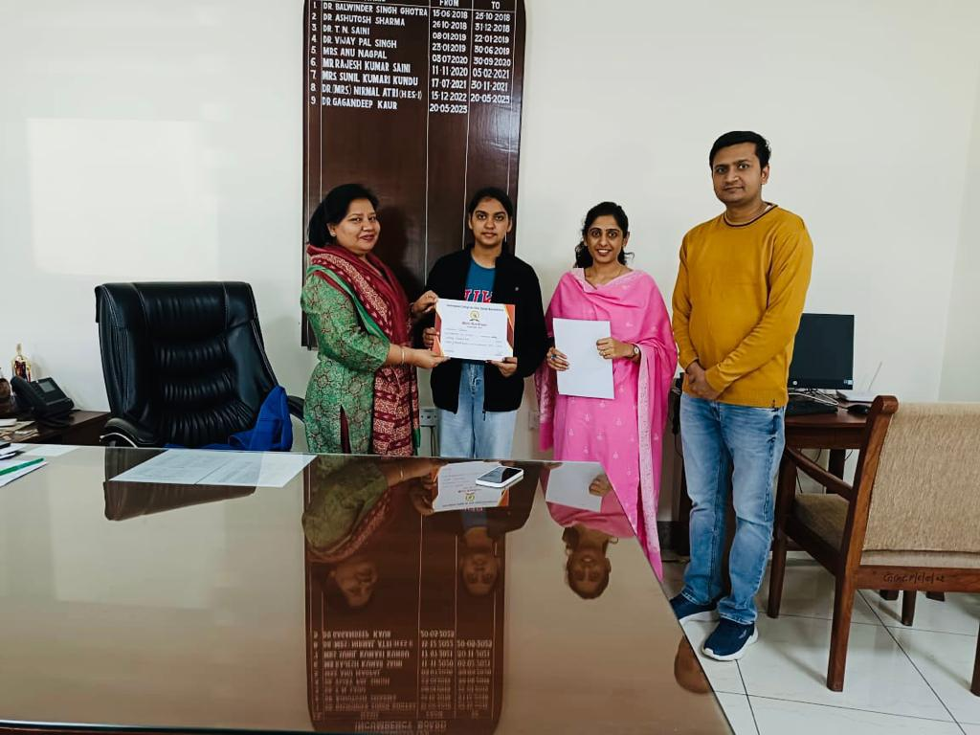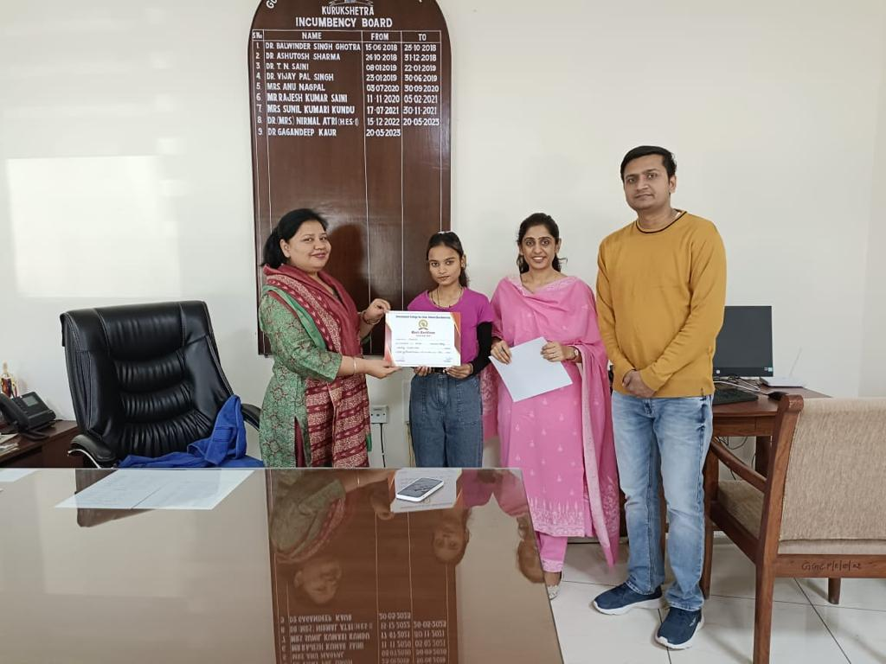
11 | Press Release/ Newspaper coverage | 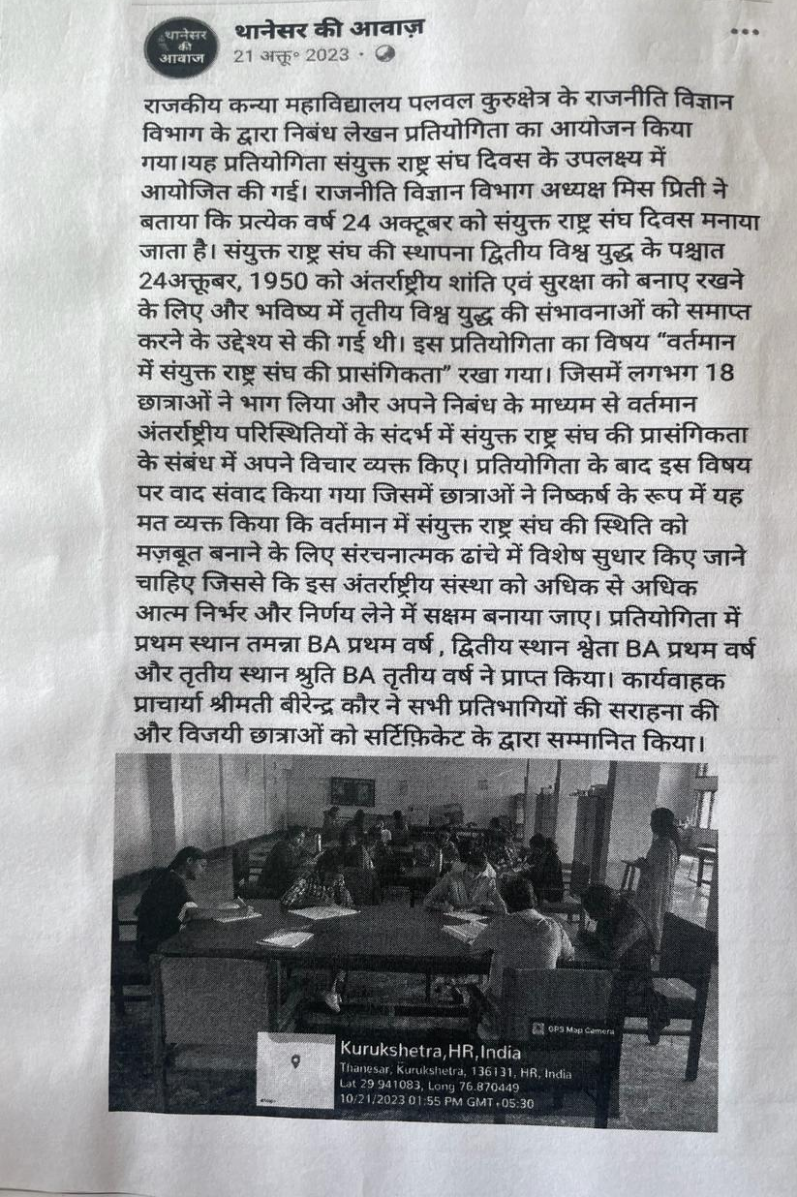

Submitted by:
Preeti
Asstt. Professor
Dept of Political Science

Event Report Performa
Govt. College for girls, Palwal, Kurukshetra

Sr. No. | Particulars | Report
1 | Event Organising Committee/Club/ Cell/ Association | Dept of Political Science
2 | Title/Topic of the Event/Theme of the event | Shaheedi Diwas
3 | Type of Event(Conference/Competition/Invited Talk) | Quiz Competition and an Extension Lecture
4 | Date & Time | Quiz competition was organized on 21-03-2024 at 1:30pm and Extension Lecture was organised on 22-03-2024.
 | Venue | Room No. 13
6 | Sr. No of Web Portal Activity Register where event is entered | Page no. 10 at Sr. no. 158 & 159
7 | No. of students/ participants | 10 Teams (3 Students each Team) participated in the quiz competition and approximately 60 students present in the extension lecture.
8 | Name and Address of Resource Person/ Guests/ Speakers/Judges | MS. Komal Garg, Asstt. Prof. of Commerce was the quiz Master.  Mr. Ravi Kumar, Asstt. Prof. of History from Govt. College Chammu Kalan (KKR) was the resource person on the 2nd day.
9 | Any Other information about the event-Brief Report | N.A.
10 | Photograph( 4 General & 2 Geotag) | 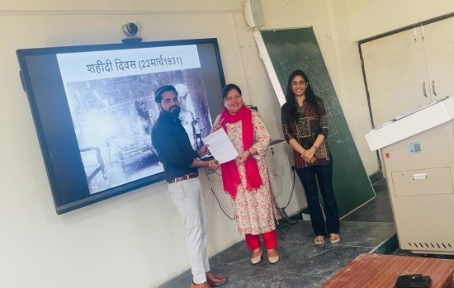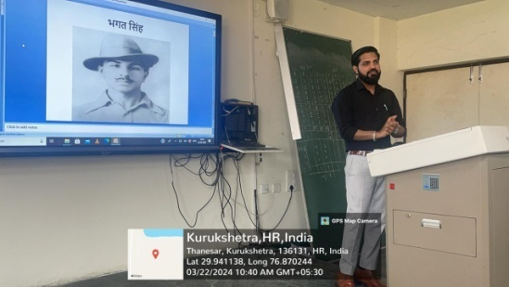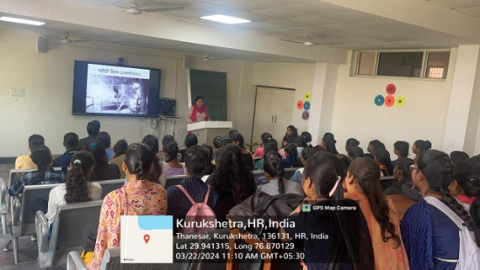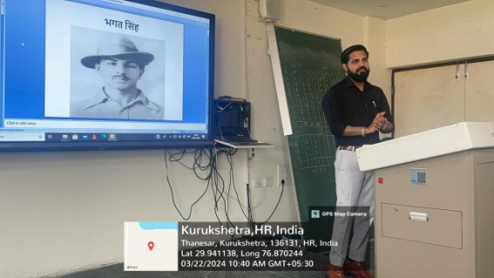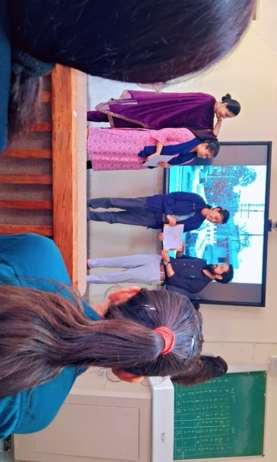  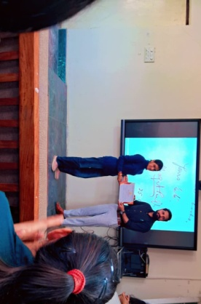
11 | Press Release/ Newspaper coverage | 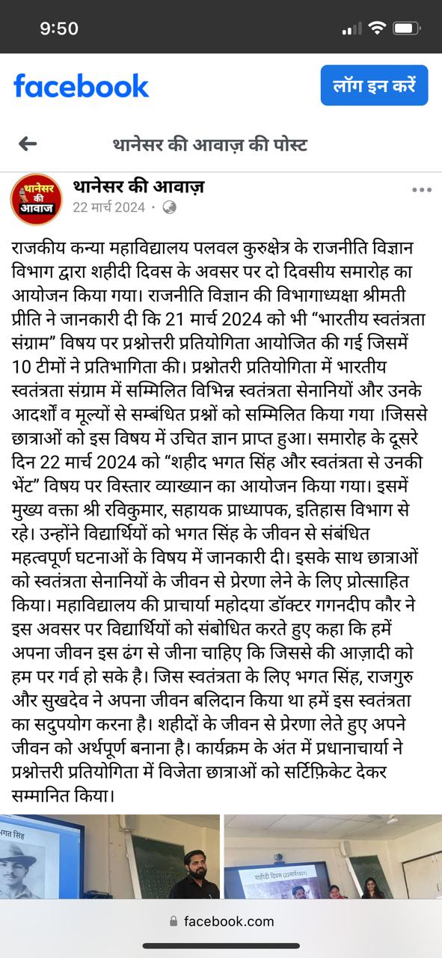

Submitted by:
Preeti
Assistant Professor
Political Science

